Clinical Practice in Athletic Training

Author Guidelines for Submission
Updated October 2025

Table of Contents
Author Submission Portal – Step 1 4
Article Submission Agreement 4
Article Submission Portal – Step 2 5
First/Given Name and Last/Family Name: 5
Institutional Affiliation: 5
Article Submission Portal – Step 3 6
Adding Authors 6
Article Submission Portal – Step 4 7
Title, Short Title, Keywords, and Disciplines 7
Article Submission Portal – Step 4 (cont) 8
Abstract 8
Cover Page Footnotes 8
Full Text of Submission 8
Cover Letter 9
Submit 9
Manuscript Templates 10
Example: 10
Title 10
Abstract 10
Content Focus 10
Headings 11
Body Text 11
General Manuscript Formatting Guidelines 12
Body Headings 12
References 12
In-Text Citations 14
Tables and Figures 14
Tables: 14
Figures: 15
Manuscript Review and Resubmission 17

Author Submission Portal – Step 1
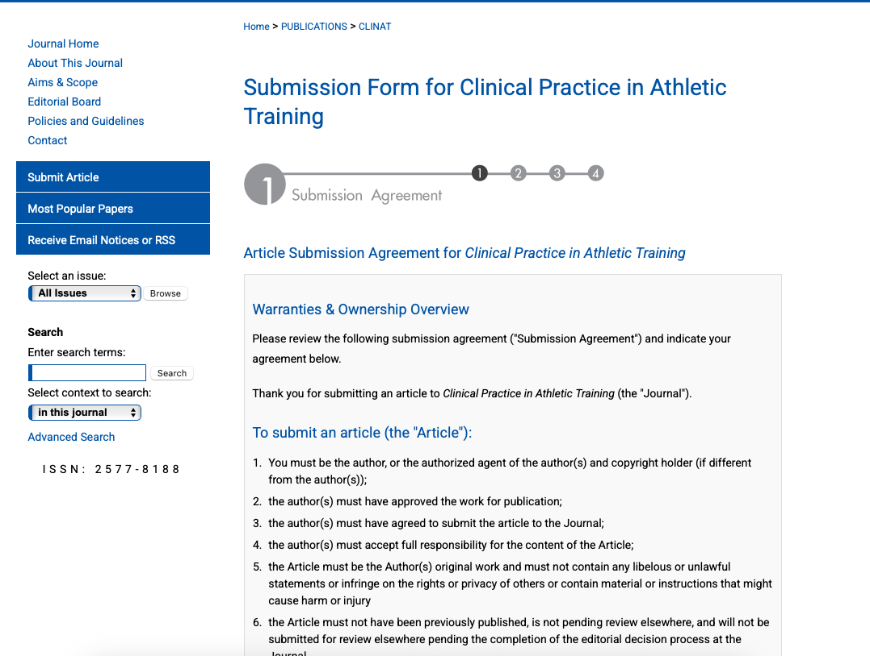

Article Submission Agreement
This is the article submission agreement that must be agreed to before submission of a manuscript. Scroll to the bottom, review the policies of the journal, and click “accept” to continue.

Article Submission Portal – Step 2
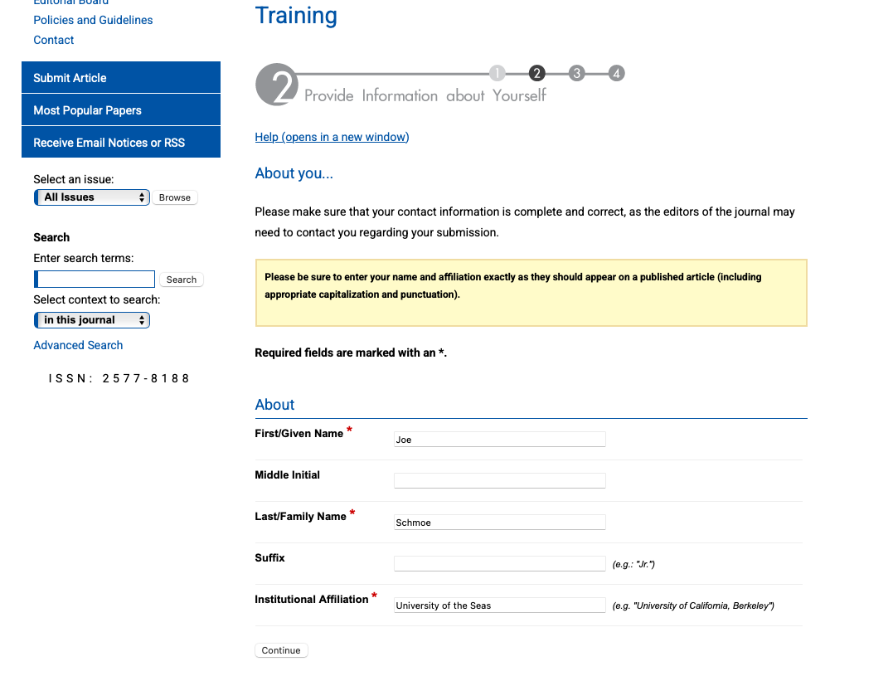

First/Given Name and Last/Family Name:
This is the name that will be attached to your submission and published within the system for indexing. This should auto-populate if you already have a Digital Commons account or have submitted previously using the same login information. This information can be changed at any time prior to publication.

Institutional Affiliation:
This is the institution that you are affiliated with at the time of submission. This should auto-populate if you already have a Digital Commons account or have submitted previously using the same login information. This information can be changed at any time prior to publication.

Article Submission Portal – Step 3
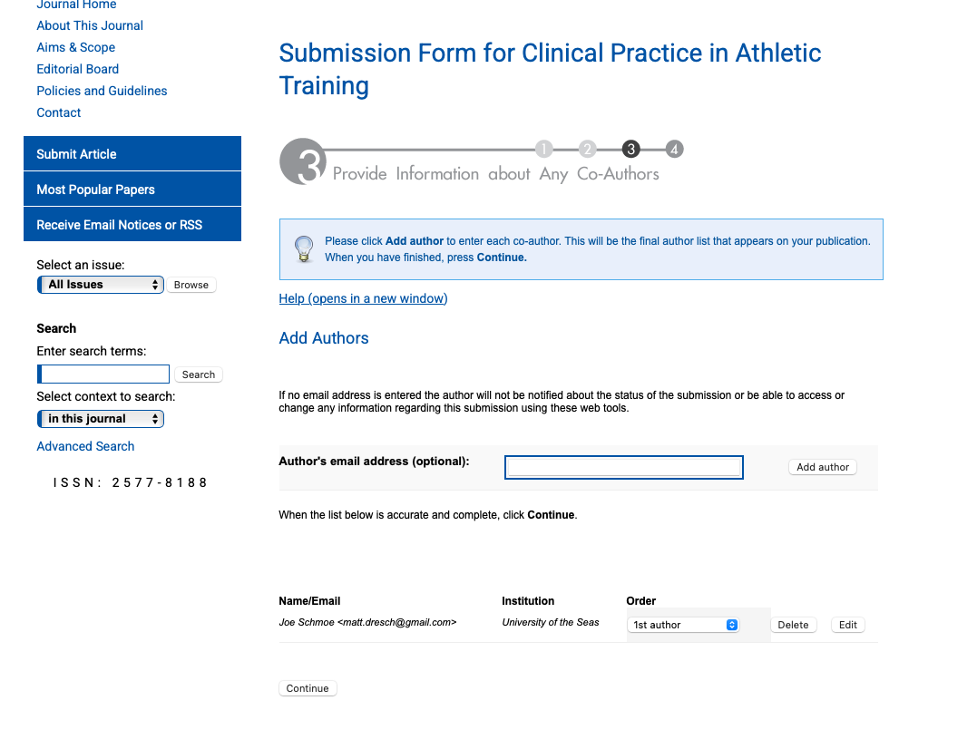

Adding Authors
This is where you can add additional authors to your manuscript. To add authors, you can either:
- Input their email address and have it auto-populate.
- Click “Add Author” and manually enter the co-author information.
If an email is not added to an author, they will not get notified of the submission and be unable to access their web portal or the submission on the ClinAT website. If a co-author does not have a ClinAT or Digital Commons account, they will be prompted to create an account on first login to the system.

Article Submission Portal – Step 4
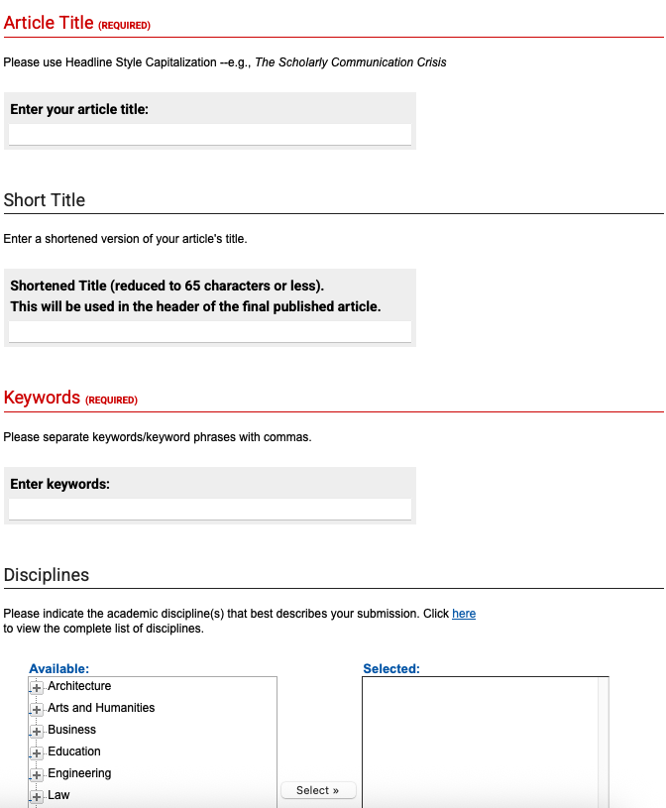

Title, Short Title, Keywords, and Disciplines
This is the first part of the article information submission in step four.
- Article Title: Please enter the full title of your submission in Headline Style (e.g. A Mixed-Methods Study).
- Short Title: This is optional.
- Keywords: Please enter 3-5 keywords that do not appear in the title to enhance indexing your article.
- Disciplines: This is optional and aids in indexing of your submission in systems like Google Scholar. This does not affect your submission to the journal.

Article Submission Portal – Step 4 (cont)
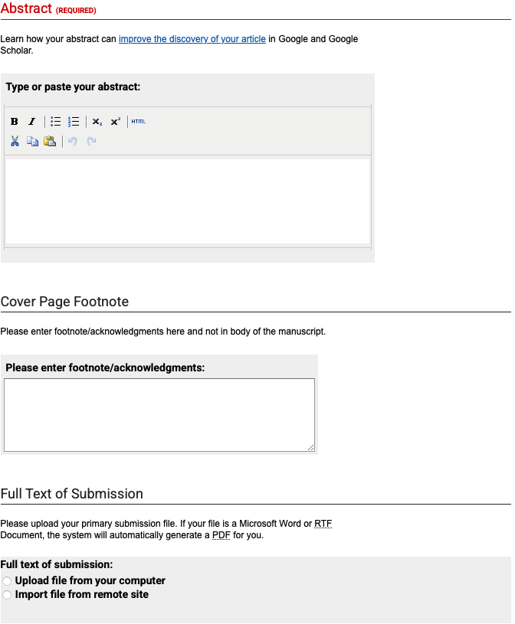
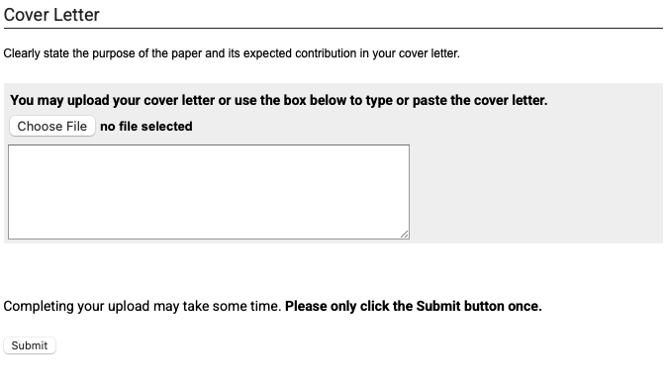

Abstract
Please copy and paste your article abstract in this box. For manuscript types that do not require an abstract, please put “N/A” in this box.

Cover Page Footnotes
This is where you can add information, such as acknowledgements or other footnote information, that will appear in the journal-generated cover page for the submission. This is not required.

Full Text of Submission
This is where you will upload a full-text copy of your submission to the journal. Please refer to Manuscript Templates for more information regarding submission. Please note:
- Submission must be de-identified and cleared of any comments, including institutional affiliation, author contact information, abbreviations of institution or author initials, and comments/track changes. This version will be sent directly to reviewers, and any identifiable information will be sent back to authors to resubmit.
- The document uploaded here must be in either a Word or RTF file format. The journal system will automatically turn the submission into a PDF document.

Cover Letter
This is where you can upload a submission cover letter. This letter should include all author information, institutional affiliations, corresponding author information, and any additional information relevant to the submission. This does NOT need to be addressed to the Editor-in-Chief.

Submit
Once your submission is ready, click the “Submit” button. This will generate the submission document and PDF document, and once submitted the authors should be able to access their submission through their account portal.

Manuscript Templates
ClinAT uses manuscript templates to expedite the review and processing time for submitted manuscripts. Below is an example of a manuscript template along with guiding information regarding the template.

Example:
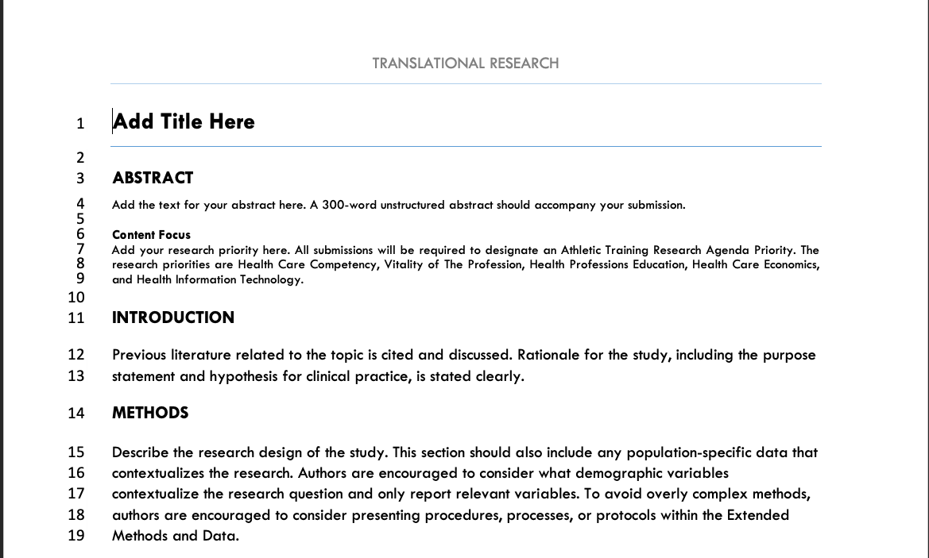

Title
Please type your title into this section, using Headline Style (i.e. A Review of Mixed-Methods Studies: A Mixed-Methods Study).

Abstract
Please copy and paste your abstract here. The journal does not use structured abstracts, so please remove all abstract headers from within the text.

Content Focus
Please select at least one of the listed research priorities: Health Care Competency, Vitality of The Profession, Health Professions Education, Health Care Economics, or Health Information Technology.

Headings
The journal templates use locked headings to ensure alignment of manuscript sections for the specific submission category. Some templates include additional or optional headings that you might not require for your submission, and these will be removed prior to final publication.

Body Text
The journal recommends using the templates as you write your manuscript. If you did not use a template, you can just copy and paste the body text into the relevant sections. Please make sure to “Keep Destination Formatting” to align with the template formatting.

General Manuscript Formatting Guidelines
The journal’s use of manuscript templates helps to reduce the burden of formatting and copyediting for both authors and journal staff. However, the templates cannot cover all cases for authors. Below are some general formatting guidelines for manuscript submissions. Following these guidelines, along with using the templates provided, will help expedite the submission and review process.
Clinical Practice in Athletic Training uses AMA Manual of Style, 11th Edition as a basis for journal formatting. General formatting principles are as follows:
- Use SI units for all measurements. If necessary, include conventional units in parentheses.
- Abbreviations: Spell out on first use; avoid in title/abstract.
- Numbers: Use numerals for numbers >9 and when presenting data.
- Voice and Style: Write in active voice where possible, maintain professional and concise tone, use past tense for methods and results.

Body Headings
- Heading 1: Full Caps, Bold, Left Justified
  - Example: INTRODUCTION
- Heading 2: Capital Case, Bold, Left Justified
  - Example: Participant Information and Recruitment
- Heading 3: Capital, Underline, Left Justified, In-paragraph
  - Example: Qualitative Results

References
- Typeface: Tw Cent MT
- Font Size:
  - Heading: 12 pt
  - Text: 11pt
- Line Spacing: Single-spaced
  - Before: 0 pt
  - After: 0 pt
- Paragraph Style: Left Justified
- References should be numbered with 3/8th inch space from numbers, no indent
- References should follow AMA Style guidelines.
- Authors should be listed as last name first and middle initial without commas or periods:
  - Correct: Schmoe JM
  - Incorrect: Schmoe, JM; ShmoeJM; Schmoe J.M.
- Commas should be used to separate two or more authors:
  - Correct: Shmoe JM, Doe JE
  - Incorrect: Schmoe, JM, Doe, JE; Shmoe JM Doe JE
- Article titles should be in sentence case, with capital letters for the first word in the title, for proper nouns, or after a colon or semicolon
  - Correct: Examples of article titles for reference: Use in Clinical Practice in Athletic Training
  - Incorrect: Examples of Article Titles for Reference: Use in Clinical Practice in Athletic Training
- Journal names should be italicized in Capital Case and use approved NLM journal abbreviations – See Appendix A and Appendix B
  - Correct: Clin Pract Athl Train
  - Incorrect: Clinical Practice in Athletic Training; Clinical practice in athletic training
- References should include minimum acceptable information for the reference type:
  - Print Journal Article:
    - Author(s). Article title. Abbreviated Journal Name. Year;vol(issue):inclusive pages. DOI
      - Schmoe JM, Doe JE. Example article for Earth. Clin Pract Athl Train. 2032;17(3):2-15. doi:10.1020/example.ref.12345
  - Online Journal Article:
    - Author(s). Article title. Abbreviated Journal Name. Publication Date. DOI
      - Schmoe JM, Doe JE. Example article: References. Clin Pract Athl Train. 2032. doi:10.1020/example.ref.12345
  - Print Book:
    - Author(s). Book Title. Edition number (if it is the second edition or later). Publisher’s name; copyright year.
      - Schmoe JM. Example for References: A Novel. Random Publishing Co; 2056
  - Online Book:
    - Author(s). Book Title. Edition number (if it is the second edition or later). Publisher’s name; copyright year. Accessed [date]. URL (or DOI, if provided)
      - Schmoe JM. Example for References: A Novel. Random Publishing Co; 2056. Accessed 21 January 2088. www.notarealwebsite.org/reference/book. doi: 10.1020/example.ref.12345
  - Website:
    - Author (or, if no author is available, the name of the organization responsible for the site). Title (or, if no title is available, the name of the organization responsible for the site). Name of the website. Published [date]. Updated [date]. Accessed [date]. URL
      - Indiana State University. Style Guide for Authors. Clinical Practice in Athletic Training. Published September 2025. Updated September 2025. Accessed 17 September 2025. www.notarealwebsite.org/reference/styleguide.htm

In-Text Citations
- Assign a superscript Arabic numeral to each reference in the order it is cited in the text.
- Use sequential numbering: the first citation is 1, the second 2, and so on.
- If a source is cited again later in the text, use the same number as its first citation—do not assign a new number.
- Place superscript numbers outside of periods and commas, and inside colons and semicolons
- Do not leave a space between the word/punctuation and the superscript number.
- When citing multiple citations:
- List citations in ascending order
- Use a comma to separate non-consecutive numbers without a space
- Use a hyphen to separate consecutive numbers in a range without a space

Correct:
“…condition is common in athletes.³”
“…these findings,^{1,3,5-7} which support…”
“…three phases²: running, jumping…”

Incorrect:
“…condition is common in athletes ³.”
“…these findings^{1, 3, 7, 5}, which support…”
“…three phases:² running, jumping…”

Tables and Figures
Place all tables and figures within body text after reference to the table or figure is made – do not submit tables and figures as separate upload documents. Tables and figures should be integrated into text rather than being placed on separate pages, unless necessary due to size.

Tables:
- Tables should be organized in AMA style formatting:
  - Set off from text by horizontal rules (horizontal bars)
  - The word “Table” and the table number are part of the table
    - Table titles should be brief and descriptive of their contents and should not summarize results or be overly detailed
  - Tables should be numbered consecutively as they appear in the text and should be positioned as close to the referring text as possible
  - Tables should only include horizontal lines, not vertical lines.
- Tables should be created using the Table function of a word processor and not use tabs/indents.
- Journal style includes a top border, bottom border, and heading bottom border
  - Individual rows should not include cell borders unless necessary for clarity
- Table title should be placed above the top border of the table
- Footnotes and captions should be included below the table as necessary
  - Footnotes are used in two circumstances:
    - Descriptive footnotes: information about the table, portions of the table, or a specific table entry
      - These should be indicated with superscript lowercase letters in alphabetical order (a-z)
    - Cite references: citations should be numbered as they are in the text using numeral superscripts
Example:
Table 1. Example Table
Category | Mean | Question 1 |  | Question 2 |  | Question 3
Category | Mean | Yes | No | Yes | No | Yes | No
Healthcare | 4.70 ± 0.6 | 4.71 ± 0.5 | 4.71 ± 0.6 | 4.71 ± 0.5 | 4.71 ± 0.6 | 4.72 ± 0.6 | 4.68 ± 0.5
Science | 4.72 ± 0.6 | 4.76 ± 0.5 | 4.71 ± 0.6 | 4.72 ± 0.6 | 4.74 ± 0.6 | 4.73 ± 0.6 | 4.72 ± 0.5
Communication | 4.68 ± 0.6 | 4.67 ± 0.7 | 4.69 ± 0.6 | 4.67 ± 0.6 | 4.74 ± 0.7 | 4.71 ± 0.6 | 4.64 ± 0.6
Engineeringª | 4.74 ± 0.6 | 4.78 ± 0.5 | 4.72 ± 0.6 | 4.74 ± 0.5 | 4.75 ± 0.6 | 4.77 ± 0.6 | 4.69 ± 0.5
Math | 4.75 ± 0.5 | 4.79 ± 0.5 | 4.73 ± 0.6 | 4.75 ± 0.5 | 4.74 ± 0.6 | 4.78 ± 0.5 | 4.69 ± 0.5
Social Sciences^{b} | 4.73 ± 0.6 | 4.78 ± 0.4 | 4.71 ± 0.6 | 4.73 ± 0.5 | 4.75 ± 0.6 | 4.76 ± 0.6 | 4.69 ± 0.5
ª denotes significance at the ≤ .05 level
^{b} category as defined by Joshton et al.²⁵

Figures:
- Provide high-resolution figures (300 dpi minimum)
- Use grayscale unless color is necessary
- Include descriptive legends below figure
  - Typeface: Tw Cent MT
  - Font Size: 11 pt
    - Title: Bold figure text, normal title text
- Figures should follow AMA style formatting
  - Figure titles should include the term “Figure” and numbered consecutively as it appears in the text. Articles that contain a single figure should just use the designator “Figure”.
  - Figure title should be placed below the figure in ClinAT journal style
  - Figure legend should be placed below or next to the figure
- When possible, original figures should be used. If a previously published figure must be used, written permission must be granted to reproduce from the copyright holder.
  - The original source should be cited in the legend with proper in-text citation.
- Figures should be inserted into the Word processing software as either an image or the “Insert Chart” function.
Example:

Figure 1. Interest in ClinAT based on the availability of the style guide

Manuscript Review and Resubmission
After a manuscript decision is made, authors will receive an email from an assistant editor regarding the decision and will be able to view reviewer comments through their author portal. are encouraged to make necessary revisions and respond to reviewer comments. For this:
- Consolidate all reviewer comments into a separate document
- Respond to comments by including line numbers with the responses.
- Do NOT leave comments or highlights within the revised submission.
Uploading these revisions to the journal system through the author portal is very similar to initial submission, with some key changes:
- Author Response to Reviewer Comment documents should be uploaded as a Cover Letter to the journal system – authors do not need to submit a second cover letter after initial submission.
- Revised manuscript documents should be submitted as a Word or RTF document in a clean format, without comments, highlights, or track changes.
Any questions regarding the submission of revisions should be directed to the assistant editor or managing editor of the journal.

